**FINAL REPORT**

**Whiskey Tango Enigma**

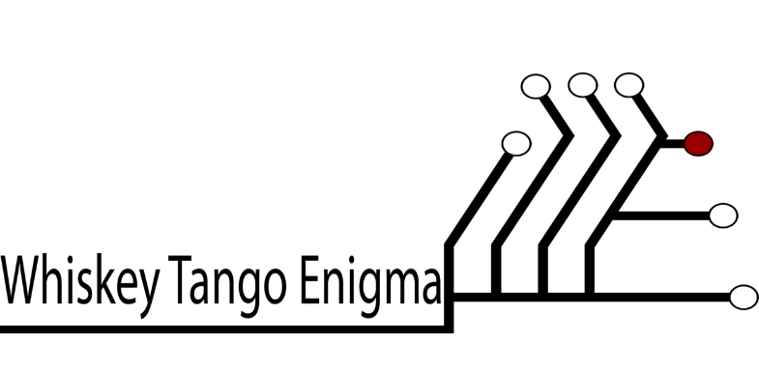

***Software Team Names***

Andrew McKissick

Anderson Nwammadi

Tellon Smith

Johann Redhead

Devin Ritter

**Wells Fargo ID system**

Team Names: Whiskey Tango Enigma

Midwestern State University

Wichita Falls, TX – 76308

**INTRODUCTION SECTION**

This document is to serve as the final report test for Card Services Software (CSS) for Wells Fargo student IDs. This document sets the scope for various problem, deviation, what we would have better if we had more time and what we learned during this project.

**Overview of project 1.1**

CSS provides routine tasks for producing Wells Fargo student IDs, collecting information about students, and producing the ID cards. CSS the student data used to produce the cards. This involves taking photos of students with Wells Fargo accounts to be uploaded using the web application. The Wells Fargo Campus Cards can be used as both debit cards and MWSU ID cards.

Description of any problems encountered and your solutions to them……….........

………………………………………………………………………………………………………………………………………………………………………………………………………………………………………………………………………

Description of any deviations from your specifications…………………………....

………………………………………………………………………………………………………………………………………………………………………………………………………………………………………………………………………

Description of any known problems remaining in your system…………………….

………………………………………………………………………………………………………………………………………………………………………………

**What we would have done if we had more time**

We would have start coding on time and also tried to communicate more with our customer as that corresponds to the system of Agile Processes, in which you give periodic updates to the customer. Another change we would have made would be to conduct more testing; one can never do enough testing. The last thing we would have done if we had extra time would be to include (place more emphasis) on the analysis, design and implementation phases of the software.

Description of what you would do different if you had it to do all over again…….

………………………………………………………………………………………………………………………………………………………………………………

………………………………………………………………………………………………………………………………………………………………………………………………………………………………………………………………………………………………………………………………………………………………

**What We Learnt**

1. The need for clear communication channels between group members, as well as the group and the client.
2. Different processes in the life cycle model and the importance of each to the overall success of the project.
3. How to work in teams, to cooperate, and to compromise.
4. The usefulness of well-defined requirements.
5. The importance of testing to the overall quality of the project.

**Summary Section**……………………….…………………………………………

………………………………………………………………………………………………………………………………………………………………………………………………………………………………………………………………………………………………………………………………………………………………………………………………………………………………………………………………………………………………………………………………………………………………………………………………………………………………………